Wiley University Alumni Couple Turns Nasal Hygiene Idea into Multimillion-Dollar Venture: From a Dusty Nightclub to a National Market
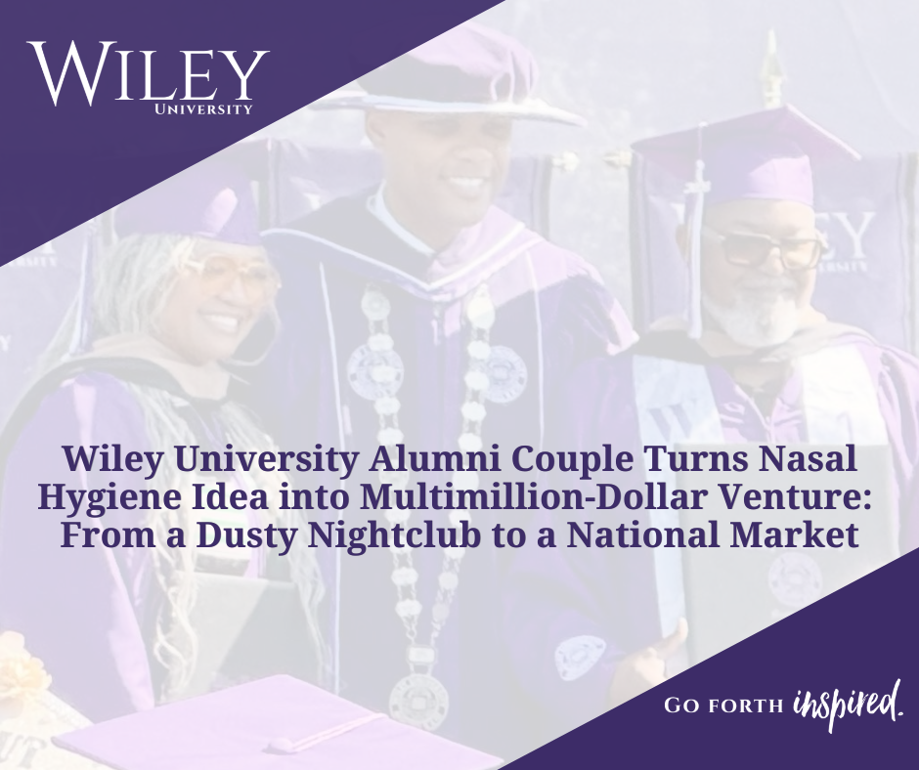
Verdell and Shawn Welch Evans developed NAZELL, a battery-powered nasal hygiene device, then sharpened their venture inside Wiley University’s MBA program, refining their Walmart pitch in their courses and presenting to industry executives in their culminating Strategic Management capstone.
FOR IMMEDIATE RELEASE
June 16, 2026
MARSHALL, TX — What began as a running joke among workers renovating a dusty nightclub has grown into a nationally recognized consumer health product, and a story that reflects the entrepreneurial spirit Wiley University's MBA program is designed to cultivate.
Verdell Evans and his wife, Shawn Welch Evans, are the creators of NAZELL, a battery-powered nasal hygiene device that has captured the attention of major investors and production companies alike. Both are proud Wiley University Wildcats, and both graduated with their Master of Business Administration degrees in May 2026.
From Idea to Enterprise
The idea was born in 2007, when the Evans purchased a nightclub, and Mr. Evans found himself searching for an effective way to clean his nasal passages after prolonged exposure to dust. Finding nothing on the market designed for that purpose, inspiration struck during an ordinary morning routine.
"I was brushing my teeth one day, and I said, 'Toothbrush, why not a nose brush?'" - Verdell Evans
Development of NAZELL spanned nearly two decades, pausing intentionally when the couple chose to adopt children and give them their full attention, reflecting the values that have guided their thirty-seven-year marriage. When the time was right, they returned to their invention with a new focus and enrolled in Wiley University's MBA program.
Wiley University's MBA: Where Ideas Become Enterprises
That decision proved transformative. Wiley University's MBA curriculum sharpened their business acumen, strengthened their investor pitch, and gave NAZELL a real runway. The refinement came in their capstone course - MGMT 5399: Strategic Management, where the Evans presented their product to a panel of seasoned industry executives and received the candid, high-level feedback that helped elevate their concept.
Their capstone instructor was Morris Thomas, Ph.D., MBA, PMP, Provost and Vice President for Academic Affairs.
"At Wiley University, we are not simply awarding credentials. We are developing innovators and entrepreneurs who solve real problems and build real ventures. Watching Mr. and Mrs. Evans refine NAZELL in our Strategic Management capstone and present it to seasoned industry executives is exactly what our MBA is designed to do: turn an idea into an enterprise." - Dr. Morris Thomas, Provost and Vice President for Academic Affairs, Wiley University
National Recognition and Investor Backing
Recognition has followed their persistence. Kevin Harrington of Shark Tank has called NAZELL a multimillion-dollar product. The couple has also secured backing from investor Brandon T. Adams and is working with a production team that includes a multi-Emmy Award-winning director associated with Big Brand Ventures on a commercial campaign set to be recorded in Tampa, Florida.
A Family Legacy Built on Wiley University
The Evans’ story is also a testament to what Wiley University alumni carry forward. Mrs. Shawn Welch Evans earned her bachelor's degree from Wiley University in 2002. The couple graduated together with their MBAs in May 2026. Their daughter is expected to follow in their footsteps, graduating from Wiley University with her own MBA in 2027.
"Wiley University has been a blessing to my family and me. We are just excited to be a part of it. We're glad to be Wildcats, and we're ready to give back." — Shawn Welch Evans
"Just because people don't agree with it doesn't mean it's not feasible. Don't stop." — Verdell Evans
NAZELL is currently available online at nazell.com. The Evans plan to pursue the business full-time as their commercial campaign launches later this year.
For more information about Wiley University, please contact Catherine G. Sellers, Executive Director of Marketing, Communications, and Brand Management, at csellers@wileyc.edu or (903) 927-3386.

___________________
About Wiley University:
Wiley University, formerly known as Wiley College, is a premier liberal arts institution related to the United Methodist Church. The University is dedicated to fostering social good and developing leaders who make a meaningful impact in their communities and beyond.

